**Project Based Learning Report**

on

Implement an Email automation system using SQL & Python

Submitted in the partial fulfillment of the requirements

For the Project based learning in (**Essentials of Data Science**)

in

Electronics & Communication Engineering

By

**2014111065 Aashish Kumar**

**2014111054 Ekakshar Joshi**

**2014111041 Vishal Dubey**

Under the guidance of Course In-charge

Prof. Dnyanesh S.Lavhkare

Department of Electronics & Communication Engineering

Bharati Vidyapeeth

(Deemed to be University)

College of Engineering,

Pune – 4110043

**Academic Year: 2021-22**

**Bharati Vidyapeeth**

**(Deemed to be University)**

**College of Engineering,**

**Pune – 411043**

**DEPARTMENT OF ELECTRONICS & COMMUNICATION ENGINEERING**

**CERTIFICATE**

Certified that the Project Based Learning report entitled, **“****Implement an Email automation system using SQL & Python”** is work done by

**2014111065 Aashish Kumar**

**2014111054 Ekakshar Joshi**

**2014111041 Vishal Dubey**

in partial fulfillment of the requirements for the award of credits for Project Based Learning (PBL) in **Essentials of Data Science Course** of Bachelor of Technology Semester IV, Electronics & Communication Engineering.

**Date: 21 May 2022**

**Prof. Dnyanesh S.Lavhkare Dr. Tanuja S.Dhope**

**Course In-charge PBL Co-Ordinator**

**Dr. Arundhati A.Shinde**

**Professor & Head**

**ELECTRONICS & COMMUNICATION ENGINEERING**

|  |  |
| --- | --- |
| **Index: -** | |
| Page No. | Contents |
| 1 | Problem Statement with Solution |
| 2 | Description about project |
| 9 | Software Used |
| 10 | Results |
| 11 | Conclusion & Outcome |

**Problem Statement :-**

What is Data Science? Why learn Data Science?

**Solution :-**

Data science is the domain of study that deals with vast volumes of data using modern tools and techniques to find unseen patterns, derive meaningful information, and make business decisions. Data science uses complex machine learning algorithms to build predictive models. The data used for analysis can come from many different sources and presented in various formats.

Data science is the field of study that combines domain expertise, programming skills, and knowledge of mathematics and statistics to extract meaningful insights from data. Data science practitioners apply [machine learning](https://www.datarobot.com/wiki/machine-learning/) [algorithms](https://www.datarobot.com/wiki/algorithm/) to numbers, text, images, video, audio, and more to produce [artificial intelligence (AI)](https://www.datarobot.com/wiki/artificial-intelligence/) systems to perform tasks that ordinarily require human intelligence. In turn, these systems generate [insights](https://www.datarobot.com/wiki/insights/) which analysts and business users can translate into tangible business value.

Reasons to learn Data Science are: -

1. Learning about data science provides an opportunity for you to recreate yourself.
2. **We live in a digital world, everything is data-driven.** There is data science in **business, accounting, education, science, engineering, healthcare, technology, energy sector, government**, and so on.
3. **Data science is also a very promising field with lots of high paying job opportunities.**
4. **Basic data science skills are important for personal use.**
5. Great potential to branch out with different options.
6. Become a decision-maker, not every job opportunity will give you the power to make informed business decisions. For a data scientist, that is the core responsibility.
7. Less competitive because it is a highly analytical role, competition is less, but demand is not. With a limited talent pool, there is always a challenge for businesses to hire in these roles.

**Implement an Email automation system using SQL & Python**

1. The use of predefined rules to trigger email messages and personalize your messages based on specific actions customers take—or don’t take, using email or marketing automation software. Some examples include when you automate welcome emails sent when a customer signs up for a mailing list, similar product recommendations after a user has bought from your site, or a quick reminder that the customer placed something in their cart but never finished checking out. Email automation takes repetitive tasks off your to-do list to free up your time for other valuable tasks, such as responding to customer questions. It can help customers learn more about your brand, encourage them to keep coming back, or remind them of why they bought from you in the first place.

**The benefits of email automation**

**Email automation lets you:**

**1. Personalize your customers’ experiences.**

**Research backs up what most marketers already know: Customers love personalization.**

**90% of consumers find personalized content very or somewhat appealing.**

**91% of consumers are more likely to patronize businesses that provide individualized recommendations and offers.**

**A recent experiment revealed that when shoppers knew an ad was based on their activity on the site, their click-through rates increased by 11% and revenue from the product grew by 38%.**

**In 2019, 72% of customers only respond to marketing messages that target their interests.**

**The leading type of personalization experience that marketers use is email.**

**With email automation you can even create a series of automated emails to help grow your relationships with your customers—and your business. Improving email marketing efficiency as a marketing channel through the sales funnel.**

**2. Make the most of your marketing team.**

**Automation is changing the way that all kinds of teams do business. According to a 2017 survey of information workers, respondents said they believe automating email marketing can improve employee productivity:**

**69% said automation could help reduce wasted time.**

**59% said that they could save at least 6 hours a week if the repetitive aspects of their job were automated.**

**72% said that they would use the time they saved to focus on higher-value work.**

**For email marketing teams, for example, this could mean less time spent on manually compiling email lists and scheduling messages. Instead, team members could use that time to focus on other important tasks, such as in-depth customer relationship building.**

**The bottom line: With automation, more gets done—and the added productivity is of higher value.**

**3. Improve your customer retention rate.**

**It's much easier and more cost effective to sell to an existing customer than to convert a new one, and with automation, you can stay in touch better than ever before. Schedule your messages so that your customers don't go too long without hearing from you—and be sure the copy is relevant to maximize its impact.**

**An email that reads “Hey, we haven't heard from you in a while. Pay us a visit!” is likely to end up in the trash. Compare that to this one:**

**"Dear Joe, we haven't heard from you in a while, and we wanted to make sure that you heard about our latest offer. The printer you’ve been buying parts for came out with a new model, and it's 20% off! Come check it out."**

**That's an example of a message that fills a need, which is more likely to bring back a customer.**

**4. It makes your marketing strategy scalable.**

**When you send out an email series manually, the size of your staff limits the number of customers that you can reach. Would you be able to stay on schedule if your customer base suddenly doubled in size? What if it tripled?**

**When you send automated emails you scale your email marketing efforts. When you've set it up so that your platform sends a message every time someone signs up for your mailing list via a custom signup form, you don't have to make sure a staff member is available to do it. Check out more email marketing campaign tips for more ideas.**

**With email automation, customers automatically integrate into your system as soon as they perform any of the actions that you track.**

**Software Used: -**

**Python: -**

Python is a high-level, interpreted, general-purpose programming language. Its design philosophy emphasizes code readability with the use of significant indentation. Python is dynamically typed, and garbage collected**.**

What is Python used for?

Python is a computer programming language often used to build websites and software, automate tasks, and conduct data analysis. Python is a general-purpose language, meaning it can be used to create a variety of different programs and isn't specialized for any specific problems.

**Sql: -**

SQL is a domain-specific language used in programming and designed for managing data held in a relational database management system, or for stream processing in a relational data stream management system.

What is SQL used for?

SQL is the most used database language, and so it can be used for almost any company that needs to store relational data. Queries within SQL are used to retrieve data from the database, but the queries vary in efficiency.

SQL is a standard language for storing, manipulating and retrieving data in databases. Our SQL tutorial will teach you how to use SQL in: MySQL, SQL Server, MS Access, Oracle, Sybase, Informix, Postgres, and other database systems.

**Result**

**import smtplib, ssl**

**smtp_server = "smtp.gmail.com"**

**port = 587 # For starttls**

**sender_email = "my@gmail.com"**

**password = input("Type your password and press enter: ")**

**# Create a secure SSL context**

**context = ssl.create_default_context()**

**# Try to log in to server and send email**

**try:**

**server = smtplib.SMTP(smtp_server,port)**

**server.ehlo() # Can be omitted**

**server.starttls(context=context) # Secure the connection**

**server.ehlo() # Can be omitted**

**server.login(sender_email, password)**

**# TODO: Send email here**

**except Exception as e:**

**# Print any error messages to stdout**

**print(e)**

**finally:**

**server.quit()**

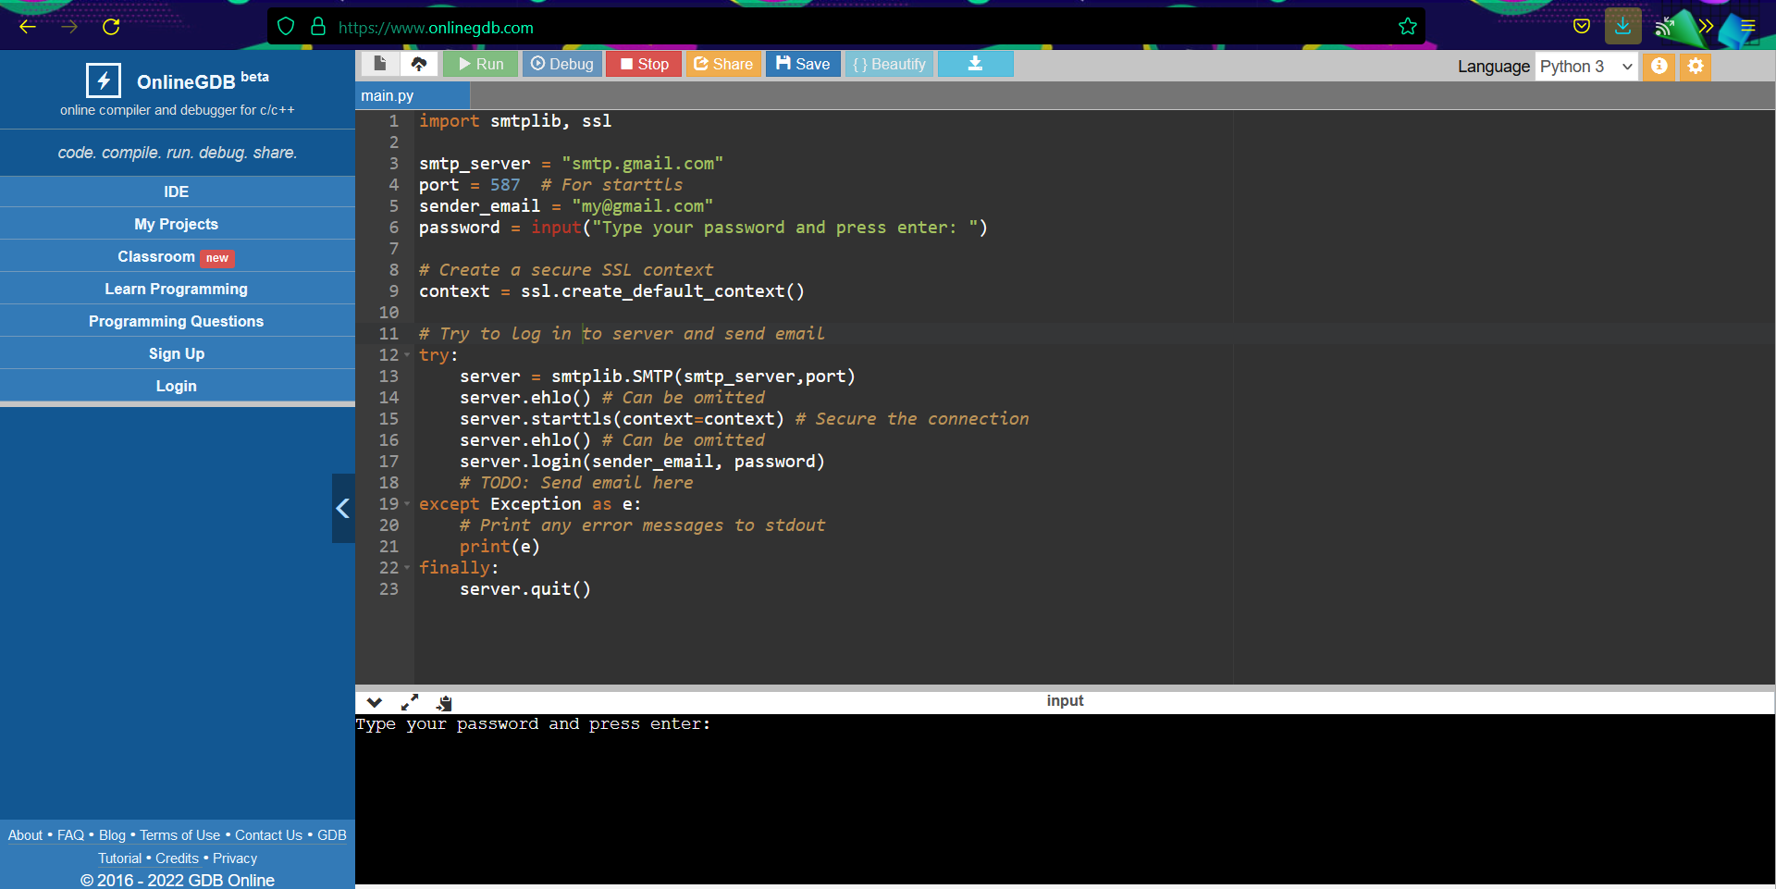

**Enter the password And a mail will be sent**

**Project Outcome: -**

From this project, we learnt to describe a flow process for data science problems and classified data science problems into standard typology. We also learnt about correlating results to the solution approach followed and assessing the solution approach.

**Project Conclusion: -**

From this project, we gained the knowledge of software – Python and Sql. We learnt to analyse the datasets and afterwards, visualizing them. We learnt about Implemention of an Email automation system using SQL & Python.